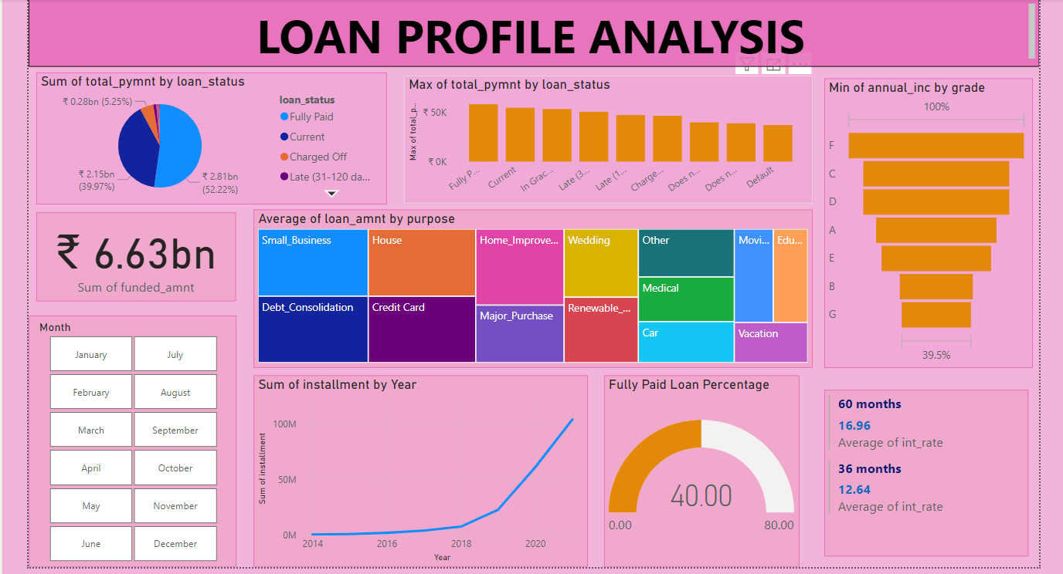

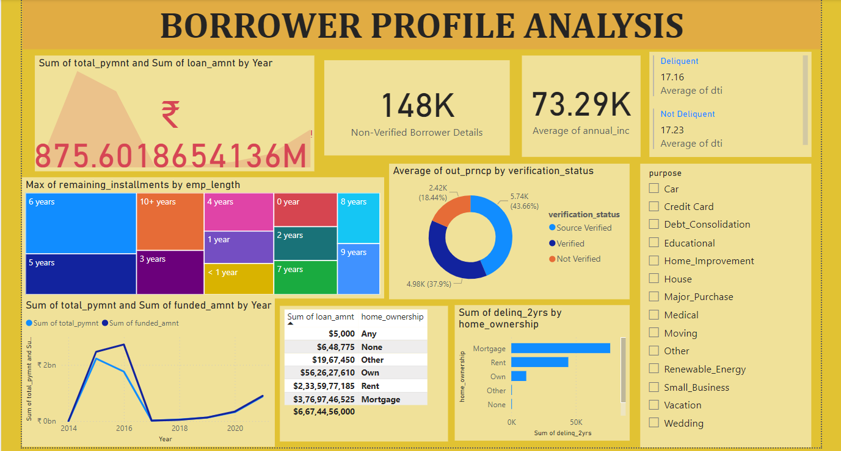**LOAN PROFILE ANALYSIS SCREENSHOT**

**BORROWER PROFILE ANALYSIS SCREENSHOT**